**Welcome to the Catholic Parishes of:**

***St. Anthony of Padua Sacred Heart of Jesus St. Margaret of Scotland***

*1432 River St. W778 County Road N N18844 Hwy 141*

*Niagara, WI 54151 Aurora, WI 54151 P.O. Box 235 Pembine, WI 54156*

*(715) 251-3879 St. Anthony office hours 9am-12noon on Thursday (715)324-5849*

*office.stanthonyniagara@gmail.com* **Website:** [**www.stanthonyniagara.org**](http://www.stanthonyniagara.org) [*stmargaretpembine@gmail.com*](mailto:stmargaretpembine@gmail.com)

 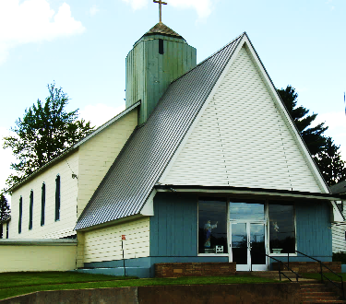 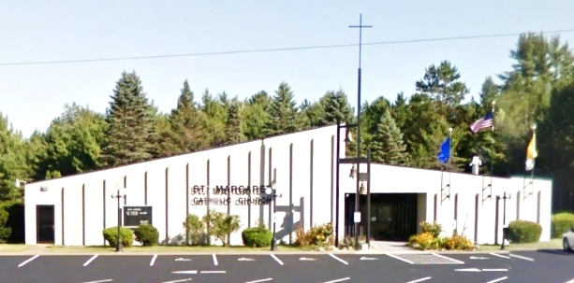

*2-Week Bulletin*

*20th Sunday*

*August 18th, 2024*

*19th Sunday*

*August 11th, 2024*

***Year B:***

***Ordinary Time***

**Our Lady of Fatima First Saturday Devotions**:

8am Adoration, First Saturday devotions, Rosary, Confessions

9am Mass, enrollment in scapular after Mass

*Next First Saturday Event: September 7th*

**CONFESSIONS**

**St. Margaret**

Friday 8:30am & Saturday 3:30pm

**St. Anthony**

Sunday at 9:00am

**Sacred Heart**

Thursday at 5:00pm

**“For my flesh is true food, and my blood is true drink”**

**“Whoever eats this bread will live forever”**

**WEEKEND MASSES**

**St. Margaret**

Saturday at 4:00pm

**St. Anthony**

Sunday at 9:00am

**Sacred Heart**

Sunday at 11:00am

**WEEKDAY MASSES**

**St. Anthony**

Wednesday at 8:00am

**Sacred Heart**

Thursday at 5:30pm (adoration 4:30pm)

**St. Margaret**

Friday at 9:00am (adoration 8am)

The Month of August is dedicated to the Immaculate Heart of Mary

O Jesus, through the Immaculate Heart of Mary, I offer you my prayers, works, joys, and sufferings of this day for all the intentions of your Sacred Heart in union with the Holy Sacrifice of the Mass throughout the world, for the salvation of souls, the reparation of sins, the reunion of all Christians, and in particular for the intentions of the Holy Father this month. Amen.

***Calendar of Events & Mass Intentions:***

**Saturday, August 10th**

3:30pm Confessions at St. Margaret

4:00pm St. Margaret Mass, Int: For the people

**Sunday, August 11th - 19th Sunday in Ordinary time**

9:30am Confessions at St. Anthony

10am Mass in the grotto, Int: Lenae Case

11am Picnic lunch hosted by Knights of Columbus

(bring a dish to pass)

**Monday, August 12th**

**Tuesday, August 13th**

5:30pm Knights of Columbus meeting in hall

**Wednesday, August 14th – VIGIL to Assumption**

10:00-11:30am Fr. Felix office hours

4:30pm Adoration, 5pm Confessions

5:30pm St. Anthony Mass int: Heather Lantagne

**Thursday, August 15th – Assumption of Mary**

8:00am St Margaret Mass, Int:

4:30pm SACRED HEART Adoration, 5pm Confession

5:30pm SACRED HEART Mass, Int: Howard Case

**Friday, August 16th**

8:00am St. Margaret Adoration, 8:30am Confession

9:00am St. Margaret Mass, Int:

**Saturday, August 17th**

11am – 3pm St. Margaret JUBILEE Celebration

3:30pm Confessions at St. Margaret

4:00pm St. Margaret Mass, Int: Al Swanson family

**Sunday, August 18th - 20th Sunday in Ordinary time**

8:30am Confessions at St. Anthony

9am St. Anthony Mass, Int: Janet Schintgen

11am Mass Sacred Heart, Int: For the people

**Monday, August 19th**

12-3pm Karen’s Pantry

**Tuesday, August 20th**

6:30pm Finance Council St. Anthony & Sacred Heart

**Wednesday, August 21st**

8:00am St. Anthony Mass, Int: Rick Tomten

10:00-11:30am Fr. Felix Office hours

**Thursday, August 22nd**

9:30am Maryhill Manor Mass

10:30am-12noon Fr. Felix office hours

4:30pm SACRED HEART Adoration, 5pm Confession

5:30pm SACRED HEART Mass, Int: Marie Galanter **Friday, August 23rd**

8:00am St. Margaret Adoration, 8:30am Confession

9:00am St. Margaret Mass, Int:

**Saturday, August 24th**

3:30pm Confessions at St. Margaret

4:00pm St. Margaret Mass, Int: Al & Gwen Mortier 50th

Anniversary

**Sunday, August 25th – 21st Sunday in Ordinary time**

8:30am Confessions at St. Anthony

9am St. Anthony Mass, Int: For the people

11am Mass Sacred Heart, Int: Bud Galanter

**Please pray for those in need of prayer.**

Jimmy Harper, John Berry, Myah Hood, Jim Butzler,  Donna Weber, Laurie Morin, Roberta Vondall, Jimmy Farrington, Donna Moreau, Mike Michaud, Kim Geib, Kaydence M. Gilbert, June Anderson, Nick DalSanto, Mary Stewart, Blake Fleury, Mark Endres, John Geib, Peter N., Lucinda Simone, Diane Rock, David Rock Sr., Geri Scheidt, Nathan Glime & family, Elias Zarate, Riley Lestrud, Elijah, Duke family, Neil Anderson, Christopher Schoon, Jenna Erno, Dan Wetzel, Eric Frantz, Ellie Mae, Keri Rugg, Steve Keeley, Debbie Ziebert, Kelly Jean Rose-Lehto, Trish Gardiner, Robin Rugg, June Uren, Marcie & Jim Crandall, Dick Doucette, Bonnie Nowland, Tom Balthazor, Jana Wood, Kathy Martin, Connor Wallace, Bob Butler, Robert Walters, Jody Wall, Roger Karban, Dan Hughes, Eric Kellings, Barb Schultz, Carol Scheidt, Al Swanson

**Nursing home:** Terry and Cheri Sweig

**Please keep our soldiers in your prayers:** Sarah Mills, David Phillips, Emily Phillips, Benjamin Oratch, Ben Garvaglia

***Please call Rose Bousley for intention 715-251-3249***

**Personnel**

Pastor (Temporary Administrator): Fr. Felix Abano, Jr.

Accountant: Cain Accounting

Secretary& RE Coord: Dawn Johnson, 715-251-1773

RE Assistant: Donna Henrichs

St A Maintenance: Randy Pilon, 920-850-6998

St A cleaning person: Veronica Church

St Margaret Secretary: Jenn Cofta

St Margaret Maintenance: Charles Kuhns

St Margaret Trustees: Andy VandenBush & Ed Nowland

Sacred Heart Trustees: Jim Carncross & Elise Neuens

St Anthony Trustees: Tony Noska & Judy Parent

**GROUP MINISTRIES**

* Karen’s Pantry Contact Teresa: 906.239.4662
* Prayer Shawl Ministry –1st Wednesday at 10am 2nd floor in SVdP room. Call Cindy Pilon 920.851.7316
* SACCW –President Laura Brinkman 906.869.8868 next mtg:
* K of Columbus –2nd Tues of month @ 5:30pm in hall
* Finance Council – next mtg: Tues, August 20, 6:30pm
* Pastoral Council -next mtg: 6:30pm
* Worship Committee – next mtg:

St. Anthony parish needs volunteers to serve on the councils. Please let us know if you can help.

**St Anthony Giving 7/8, 7/14, 7/21, 7/28**

(Weekly exp =$2,750)

Collection: $1,792; $1,323; $1,105; $2,942

**Saint Margaret Giving 8/3/24**

Collection: $848

**Sacred Heart Giving 7/14 and 7/21**

Collection: $141 and $156

**Weekly Bible Reading for Mass:**

**Sun the 11th:** Psalter III, Ordinary Time Week 19.

1 Kgs 19:4-8; Ps 34:1-9; Eph 4:30-5:2; Jn 6:41-51

**Mon the 12th**: Ez 1:1-28; Ps 148:1-14; Mt 17:22-27

**Tue the 13th:** Optional memorial of Pontian, pope and martyr; Hippolytus, priest and martyr.

Ezek 2:8-3:4; Ps 119:14-131; Mt 11:29; Mt 18:1-14

**Wed the 14th:** Vigil of The Assumption.1Ch 15:3-16, 16:1-2;P 132:6-14; 1Co 15:54-57; Lk 11:27-28

**Thu the 15th:**  Solemnity of The Assumption.

Rev 11:19, 12:1-10; Ps 45:10-16; Luke 1:39-56

**Fri the 16th:**  Stephen of Hungary.

Ezek 16:1-63 or 16:59-63; Isa 12:1-6; Matt 19:3-12

**Sat the 17th:** Ez 18:1-32; Ps 51:12-19; Mt 19:13-15

**Sun the 18th:** Psalter IV, Ordinary Time Week 20.

Prov 9:1-6; Ps 34:1-7; Eph 5:15-20; John 6:51-58

**Mon the 19th:**  John Eudes, priest.

Ezek 24:15-23; Deut 32:18-21; Mt 19:16-22

**Tue the 20th:** Bernard, abbot and doctor.

Ezek 28:1-10; Deut 32:26-36; Mt 19:23-30

**Wed the 21st:**  Memorial of Pius X, pope.

Ezek 34:1-11; Ps 23:1-6; Heb 4:12; Mt 20:1-16

**Thu the 22nd:** Queenship of Mary.

Ezek 36:23-28; Ps 51:12-19; Ps 95:8; Mt 22:1-14

**Fri the 23rd**: Rose of Lima, virgin.

Ezek 37:1-14; Ps 107:1-9; Ps 25:4-5; Mt 22:34-40

**Sat the 24th:** Feast of Bartholomew, apostle.

Ezek 43:1-7; Ps 85:9-14; Mt 23:1-12

**Candle Intentions for St. Anthony**

Infant Prague – Special Intention

Infant Prague – Walter & Hester Rucinski

**Candle Intentions for St. Margaret**

Sanctuary- Carmen & Fred Rhodes

Blessed Virgin – Francine Stanek

**BISHOP’S APPEAL 2024:**

St. Anthony’s goal is $7,486 ($4,759 donated) and St. Margaret’s goal is $3,544 ($2,875 donated). Sacred Heart members, please feel free to use the cards provided to make a donation to one of your sister parishes.

**Sacred Heart and St. Anthony will have a combined Mass in the Grotto on August 11th at 10:00am followed by a picnic hosted by the Knights of Columbus (please bring a dish to pass)**

**Barb Kimme Memorial Traveling Rosary for Vocations:** Everyone is invited to attend the Green Bay Diocesan Council of Catholic Women sponsored prayer service to raise an awareness of our Diocesan Priestly Vocation Shortage. Every 2nd Wed of the month from March – November we will gather for prayer and inspiration at nine different churches throughout the diocese. The agenda includes Intro, rosary for vocations, speaker, and reception. Our ninth date and location is: Wed, Nov 8 at St. Jude the Apostle Parish/Sacred Heart Church, 519 Knapp St., Oshkosh 54904; 1:00 – 2:30 PM. Fr. Louis Golamari will be our speaker. More info Contact 920-323-3243 or visit [www.gbdccw.org](http://www.gbdccw.org).

**Thank you** to those members of our community who attended the August 3rd diocesan training in Crivitz. If there is anyone else who would like to be officially commissioned by the bishop for their role as Extraordinary Minister in the parish or to bring the Eucharist to someone who is homebound contact Fr. Felix or Dawn. There will be another training at a future date in Crivitz specifically for those who would be willing to bring Communion to those who are homebound. Moving forward, one must be commissioned by the bishop to bring Communion to any homebound person (even if related).

**St. Margaret** is happy to welcome Jenn Cofta as the new secretary. Thank you and welcome, Jenn!

**Religious Education Registrations** should be arriving soon. If you do not receive your registration and would like to register your child, please contact Dawn.

**Confirmation and First Eucharist**

Please let Dawn know if you or your child is seeking sacramental preparation classes for First Communion or Confirmation this school year. Confirmation is scheduled for Wednesday, May 21st at 6:30pm at St. Mary in Crivitz. Other dates, places, and times are available for those unable to attend this date.

**2024 Year of Prayer**: Pope Francis named 2024 the Year of Prayer in anticipation of 2025, which will be a Jubilee Year. This year is a perfect time to form the habit of daily (and even continual) prayer. St. Paul teaches us, “*Train yourself for devotion, for, while physical training is of limited value, devotion is valuable in every respect, since it holds a promise of life both for the present and for the future*” (1 Tim 4:7-8). Just as we need to care for our bodies with healthy eating and exercise, so much more do we need to train our souls to acquire spiritual maturity. Take time in this mid-point of 2024 to consider ways to either form the daily habit of prayer or enrich your already established habit of daily prayer.

St. Margaret of Scotland - celebrating our 50th Anniversary

Saturday, August 17th from 11am-3pm

Burgers and brats,

Booyah and beer

50/50 raffle and Basket Raffles

4pm Mass with Bishop David Ricken

300 Raffle tickets printed. $50 per ticket

Mark your Calendar **for Knights of Columbus Steak Fry** on Saturday, September 28, 2024 from 4-7pm at St. Anthony Parish Hall

**Thank you** to the Knights for the donation of $1000 for the entrance mats at St. Anthony Parish. We really appreciate being able to order new mats

The **Knights of Columbus** is hosting the Mass and Picnic in the Grotto this Sunday, August 11th starting with the 10am Mass in the grotto (weather permitting) and followed by a picnic. Please bring a dish to pass.

Maryhill Manor’s 60th Anniversary Mass has been rescheduled for Thursday, September 12 at 9:30am.  Fr. John Girotti, Vicar General and Moderator of the Curia for the Diocese of Green Bay, will officiate.

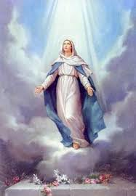

**The Assumption of Mary** on August 15th is a Holy Day of Obligation. The Mass schedule for the 3 parishes is as follows:

5:30pm Wed, at St. Anthony

8:00am Thurs, at St. Margaret,

then 5:00pm at Sacred Heart

Raffle prizes:

1st: $5000

2nd $500

3rd-10th $250

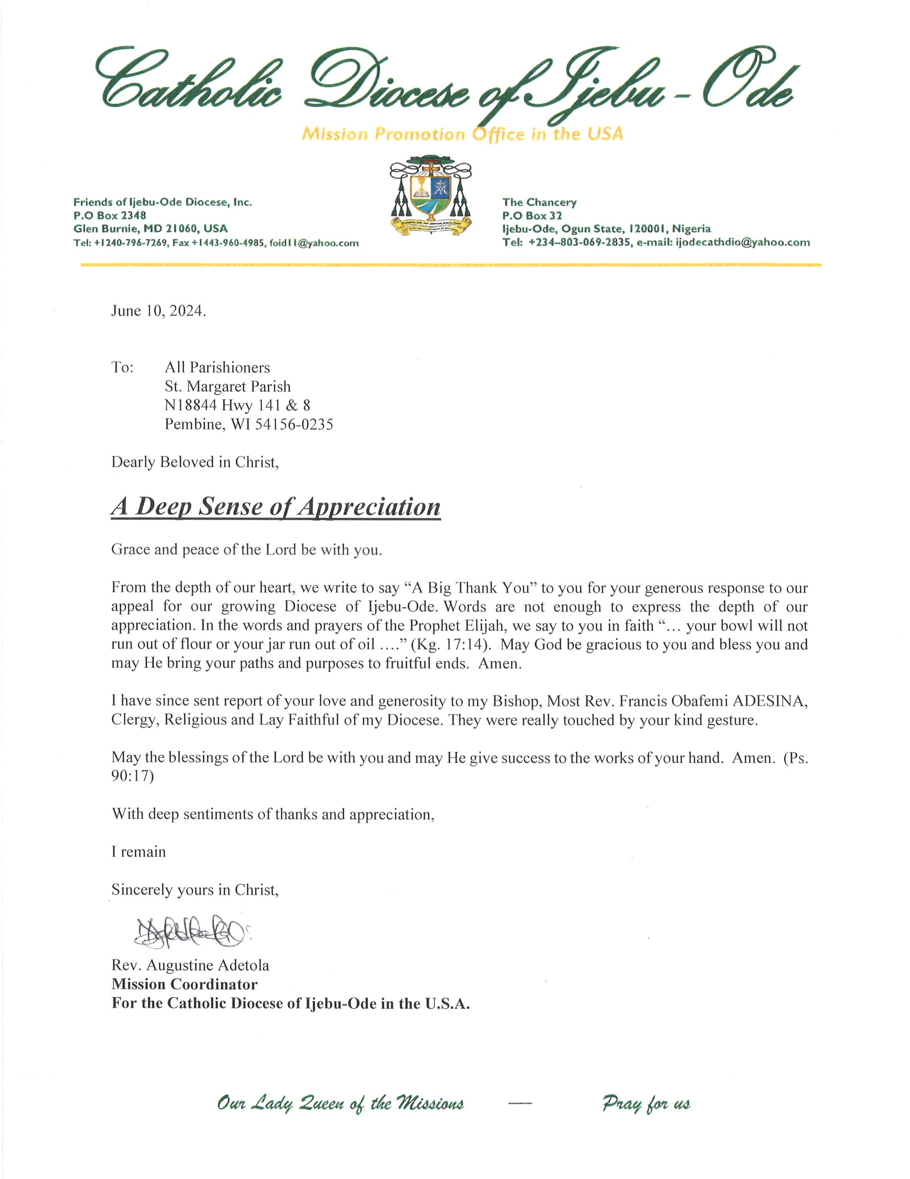

To all parishioners of St. Anthony, Sacred Heart, and St. Margaret

**LORETTA’S CATERING**

Friday Fish Fry

700 IRON ST. NORWAY, MI 49870

**(906) 563-9728**



Perry Jacobs

Owner/Director

Call 715-251-4100

1-866-774-6166

**www.jacobsfuneralhomes.com**



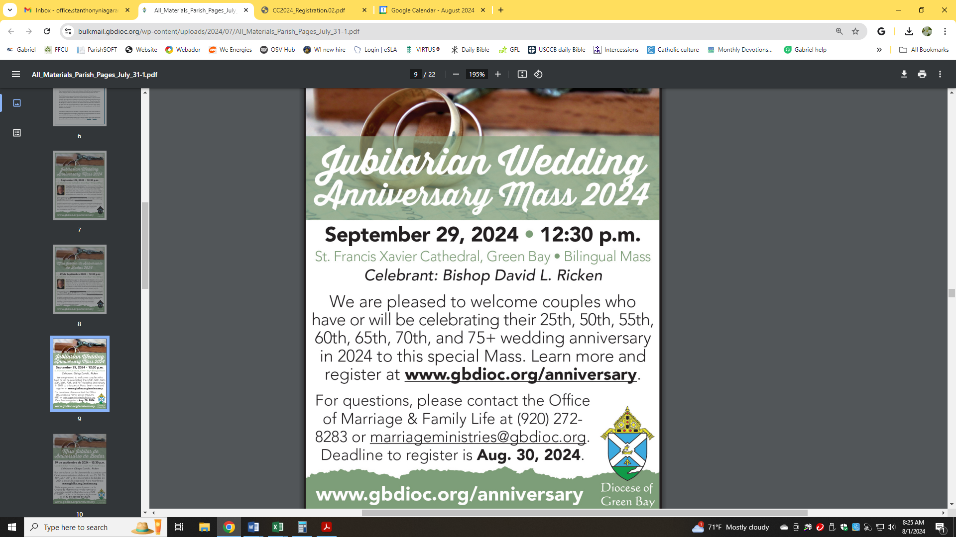

**Evergreen Assisted Living**

**Dignified Retirement Living**

*Complete Private Apartments - 3 Meals Daily - Transportation - Medicine Management - Emergency Call System – Memory Care Available*

**774-8943 * 1820 Mary’s Way, Kingsford**

***Stop in for a personal tour!***

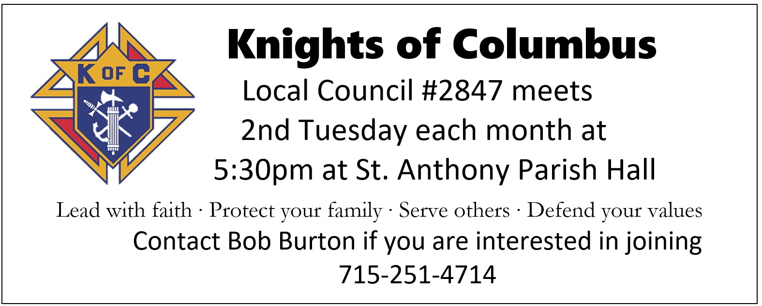

**In Loving**

**Memory of**

**Jim Merritt**



**AA Serenity Group**

**Wednesday 7:30pm at**

**St. Margaret Parish**

***Call Don 715-929-0011***

Advertise

here..



In Loving Memory of

***Jim & Mary***

***Parent***



***In Loving Memory of:***

***Blaine Johnson***



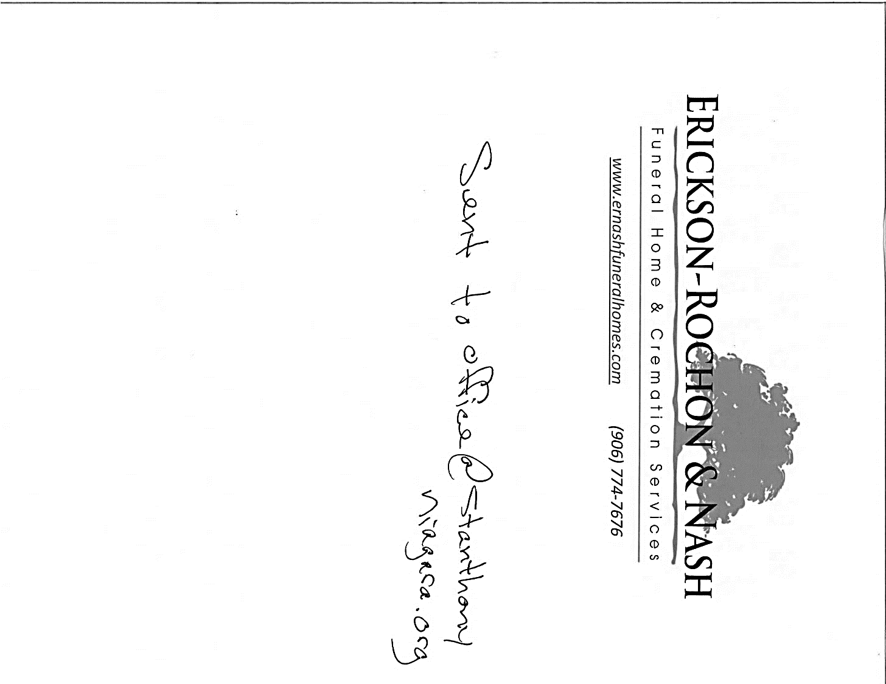

***Deceased Members***

***of the Brinkman Family***

In Memory of the Deceased Members of the

***Kadulski Family***





***Loving***

***Memory of:***

***Pat & Kathy Recl a***

